CONTENTS

LANDING PAGE 2

GITHUB REPOSITORY 3

RIPO LINK 3

LANDING PAGE
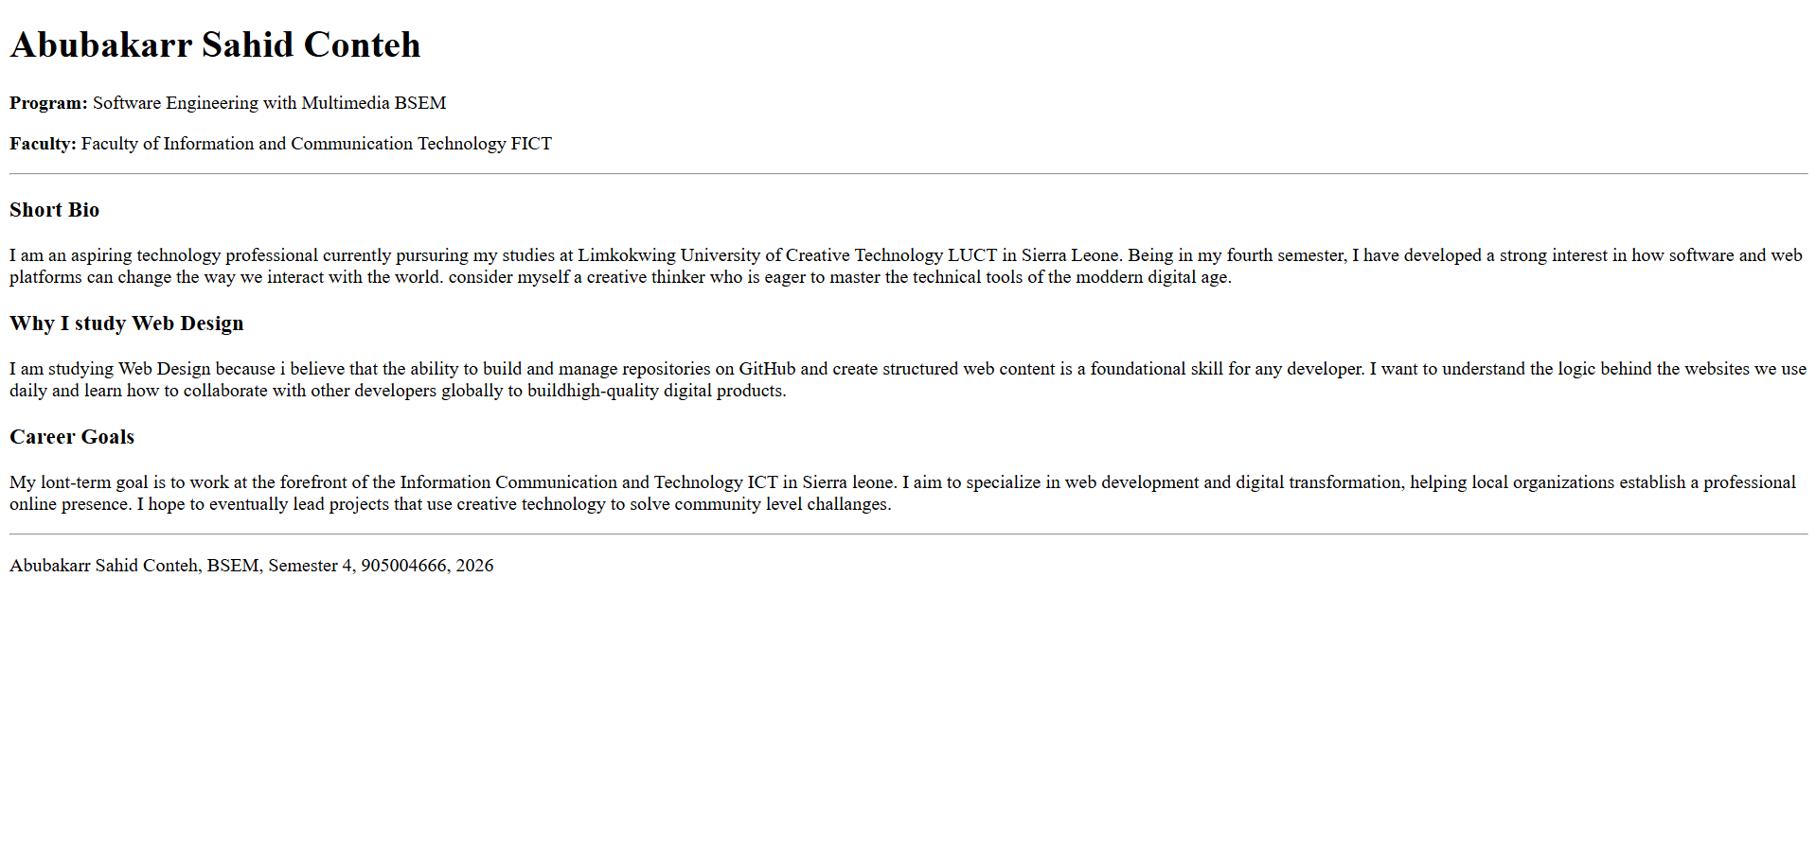

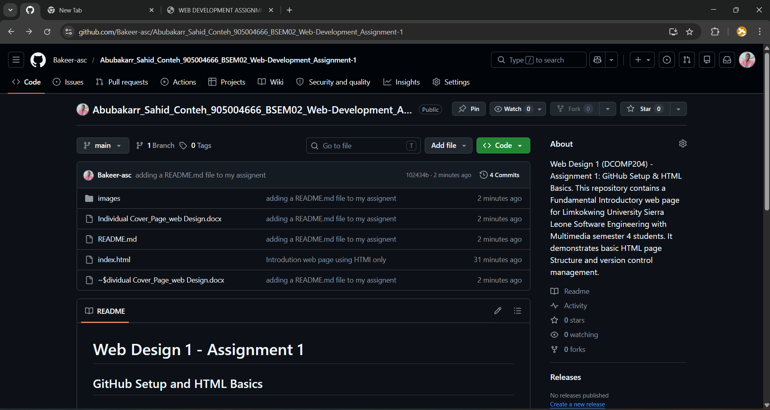
GITHUB REPOSITORY

RIPO LINK

https://github.com/Bakeer-asc/Abubakarr_Sahid_Conteh_905004666_BSEM02_Web-Development_Assignment-1
Abubakarr_Sahid_Conteh_905004666_BSEM02_Web-Development_Assignment-1

